
Touchstones Project
Netcards

Trust Netcards with Text

Baby Duck HRJ
Baby HRJ
Black Lives Matter HRJ
Blindfold HRJ

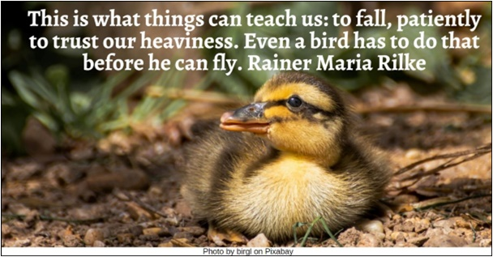

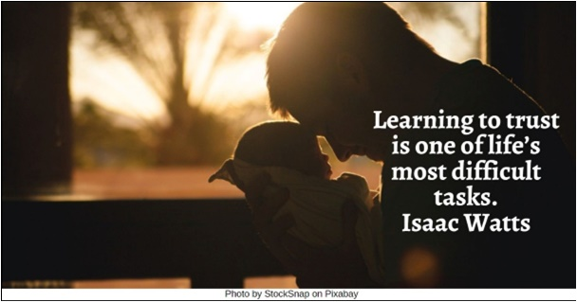

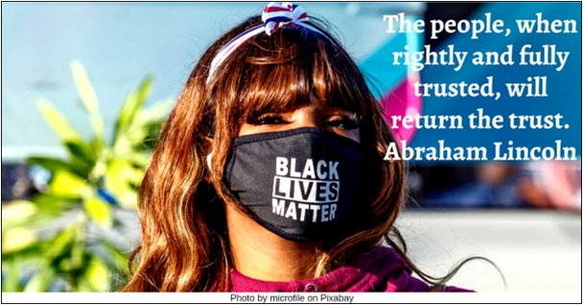

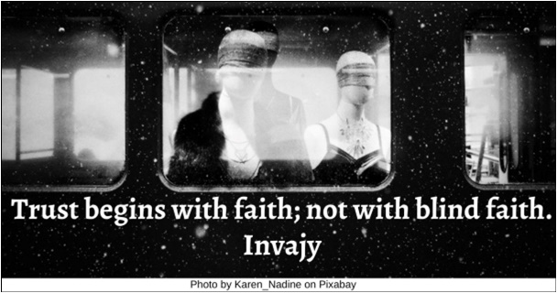

Books HRJ
Bribing Dog HRJ
Broken Heart HRJ
Broken HRJ

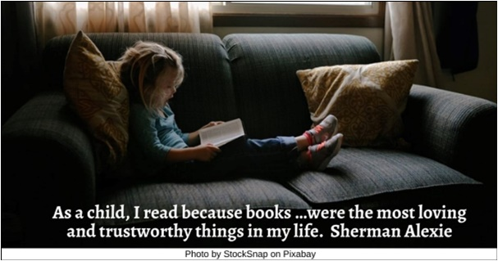

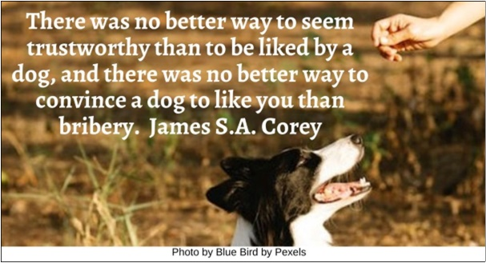

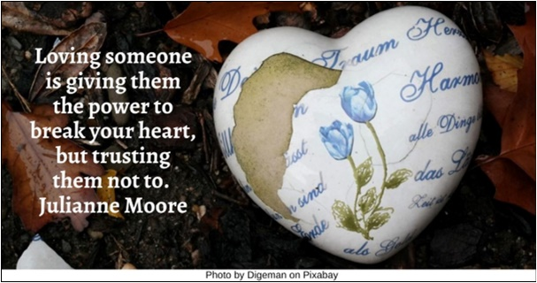

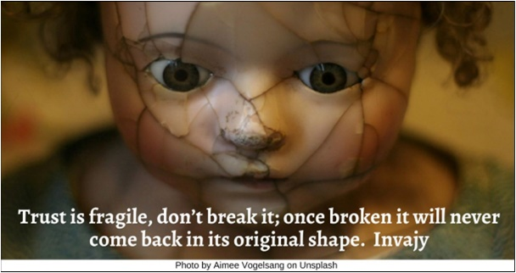

Door HRJ
Dream HRJ
Eyes HRJ
Fantasy HRJ

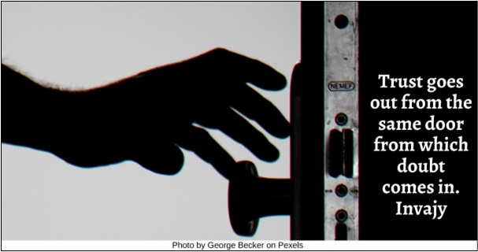

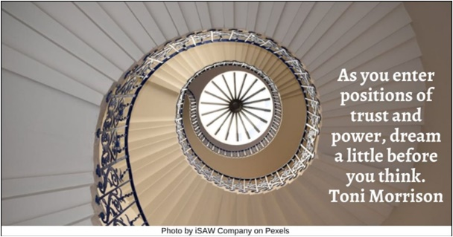

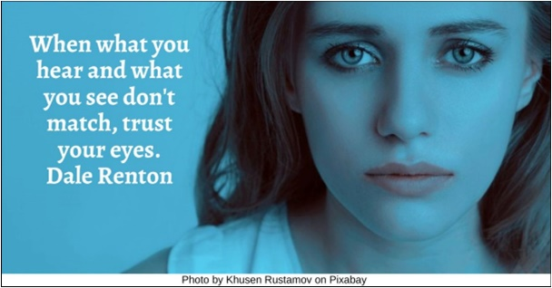

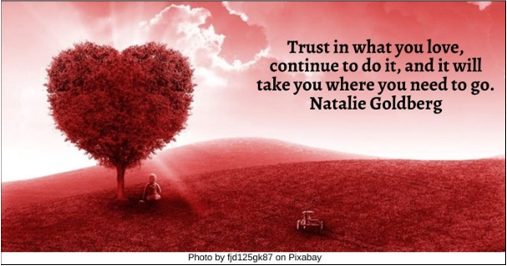

Forgiveness HRJ
Gas Can HRJ
Hourglass HRJ
James Baldwin HRJ

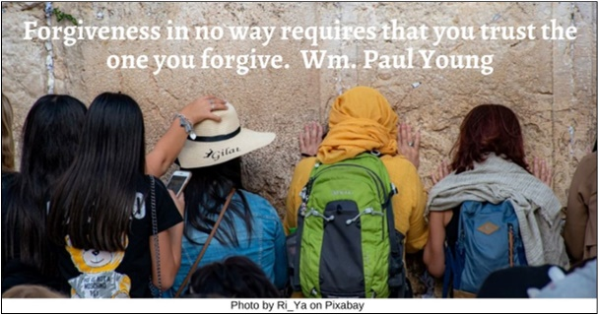

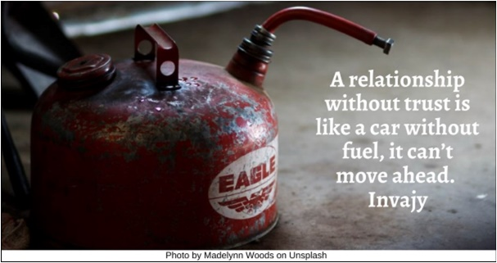

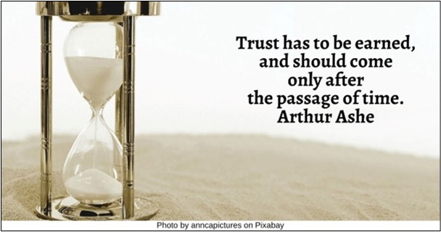

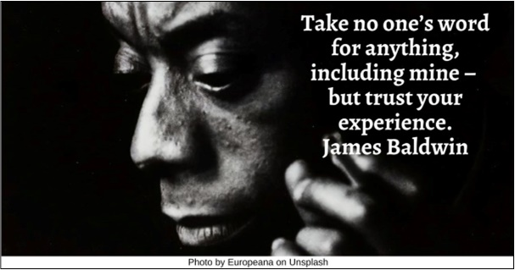

Lies HRJ
Love HRJ
Mask HRJ
Maya Angelou HRJ

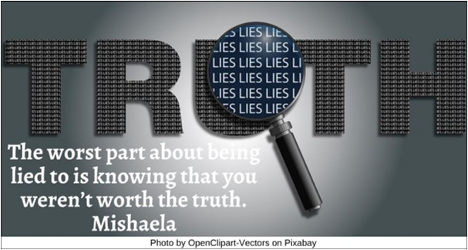

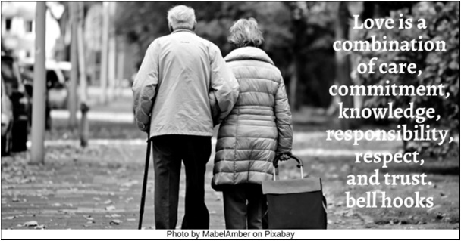

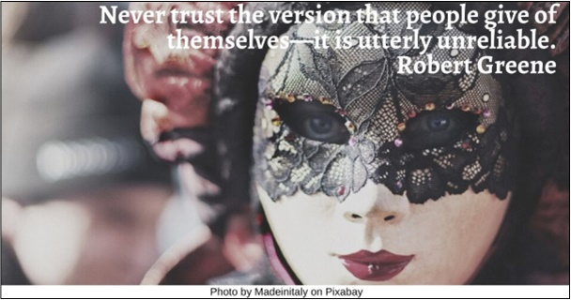

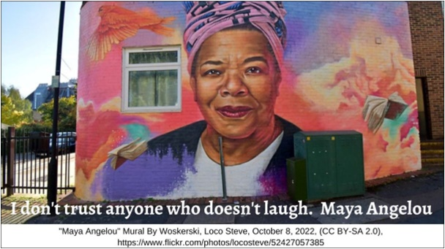

Money HRJ
Oil Can HRJ
Old Couple HRJ
Old shoes HRJ

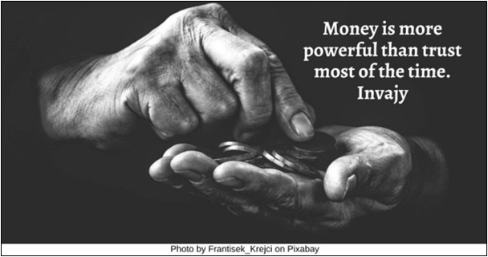

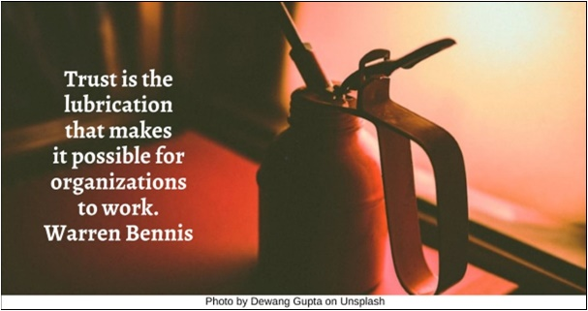

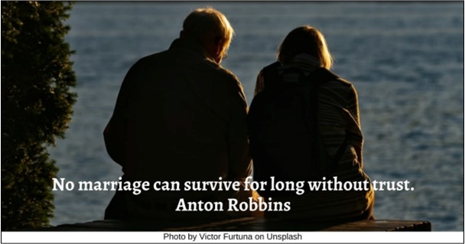

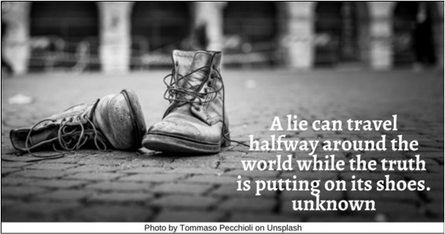

Peter Pan HRJ
Politics HRJ
Possibility HRJ
Prison Cell HRJ

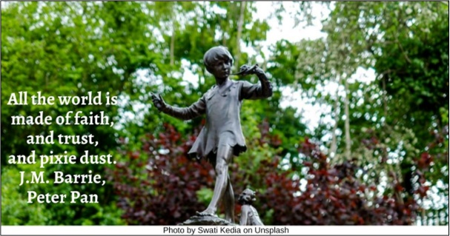

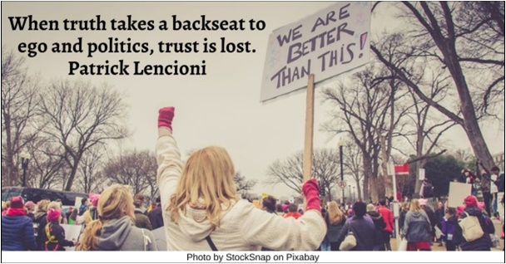

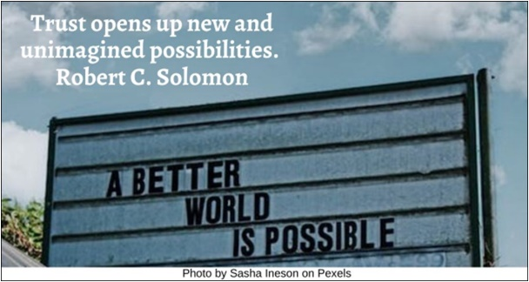

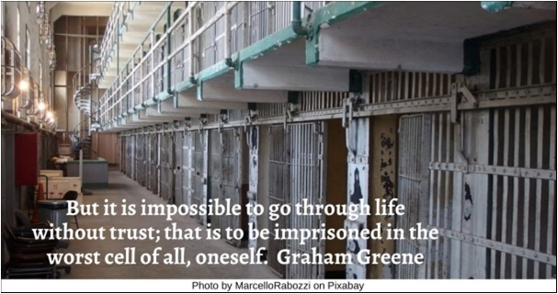

Trust HRJ
Water HRJ
Witch HRJ

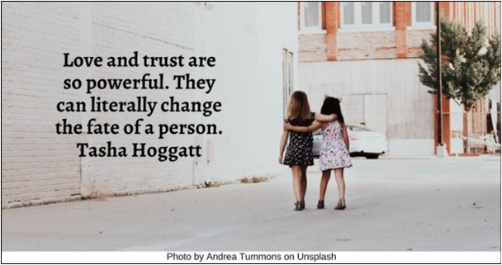

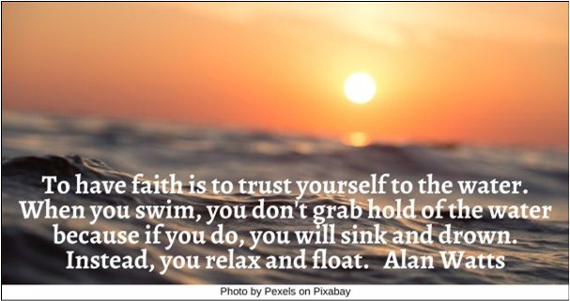



Text of Quotes

Baby Duck HRJ
This is what things can teach us: to fall, patiently to trust our heaviness. Even a bird has to do that before he can fly. Rainer Maria Rilke

Baby HRJ
Learning to trust is one of life’s most difficult tasks. Isaac Watts

Black Lives Matter HRJ
The people, when rightly and fully trusted, will return the trust. Abraham Lincoln

Blindfold HRJ
Trust begins with faith; not with blind faith. Invajy

Books HRJ
As a child, I read because books …were the most loving and trustworthy things in my life. Sherman Alexie

Bribing Dog HRJ
There was no better way to seem trustworthy than to be liked by a dog, and there was no better way to convince a dog to like you than bribery. James S.A. Corey

Broken Heart HRJ
Loving someone is giving them the power to break your heart, but trusting them not to. Julianne Moore

Broken HRJ
Trust is fragile, don’t break it; once broken it will never come back in its original shape. Invajy

Door HRJ
Trust goes out from the same door from which the doubt comes in. Invajy

Dream HRJ
As you enter positions of trust and power, dream a little before you think. Toni Morrison

Eyes HRJ
When what you hear and what you see don't match, trust your eyes. Dale Renton

Fantasy HRJ
Trust in what you love, continue to do it, and it will take you where you need to go. Natalie Goldberg

Forgiveness HRJ
Forgiveness in no way requires that you trust the one you forgive. Wm. Paul Young

Gas Can HRJ
A relationship without trust is like a car without fuel, it can’t move ahead. Invajy

Hourglass HRJ
Trust has to be earned, and should come only after the passage of time. Arthur Ashe

James Baldwin HRJ
Take no one’s word for anything, including mine – but trust your experience. James Baldwin

Lies HRJ
The worst part about being lied to is knowing that you weren’t worth the truth. Mishaela

Love HRJ
Love is a combination of care, commitment, knowledge, responsibility, respect and trust. bell hooks

Mask HRJ
Never trust the version that people give of themselves—it is utterly unreliable. Robert Greene

Maya Angelou HRJ
I don't trust anyone who doesn't laugh. Maya Angelou

Money HRJ
Money is more powerful than trust most of the time.” Invajy

Oil Can HRJ
Trust is the lubrication that makes it possible for organizations to work. Warren Bennis

Old Couple HRJ
No marriage can survive for long without trust. Anton Robbins

Old shoes HRJ
A lie can travel halfway around the world while the truth is putting on its shoes. unknown

Peter Pan HRJ
All the world is made of faith, and trust, and pixie dust. J.M. Barrie, Peter Pan

Politics HRJ
When truth takes a backseat to ego and politics, trust is lost. Patrick Lencioni

Possibility HRJ
Trust opens up new and unimagined possibilities. Robert C. Solomon

Prison Cell HRJ
But it is impossible to go through life without trust; that is to be imprisoned in the worst cell of all, oneself. Graham Greene

Trust HRJ
Love and trust are so powerful. They can literally change the fate of a person. Tasha Hoggatt

Water HRJ
To have faith is to trust yourself to the water. When you swim, you don't grab hold of the water because if you do, you will sink and drown. Instead, you relax and float. Alan Watts

Witch HRJ
Never put your faith in a Prince. When you require a miracle, trust in a Witch. Catherynne M. Valente

